Dover White Marble: Imported Premium White Marble from Namibia for Elegant Spaces

Meta Title:
Dover White Marble | Imported White Marble from Namibia in Delhi

Meta Description:
Discover Dover White Marble, a premium Namibia white marble ideal for luxury interiors, flooring, and elegant spaces. Explore imported white marble slabs at Malani Marble Pvt. Ltd.

URL Slug:
dover-white-marble-namibia-imported-white-marble

Each type of white marble has a different visual impression; some are too basic, while others have pronounced veins, which will be the main focal point of an area. The distinguishing characteristic of Dover White marble is that it provides a rare combination of a soft, clean, white background with subtle natural movement, which brings out the best aspects of interior designs without overpowering them.
Sourced from Namibia, Namibian White Marble is known for its durability, consistency, and understated elegance. It transforms a room and does so without being loud; it feels timeless, elegant, and calm. Imported Dover white marble creates a quiet luxury feel whether used in residential or commercial spaces—this is something that designers are constantly trying to accomplish.
At Malani Marble, we have seen a steady increase in the number of architects using this marble, who want classy designs but no extravagance. Aesthetics aside, there are more advantages to using premium materials in the design of a space.
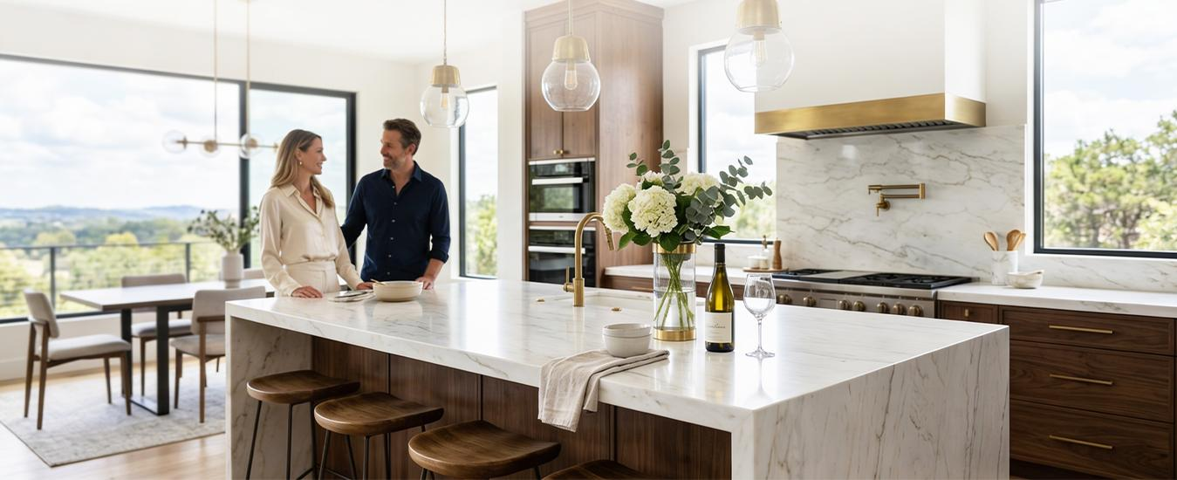

What Makes Dover White Marble a Premium Choice?
The origin, makeup, and finishing of where imported white marble comes from are what create its beauty, which makes Dover White have all the proper qualities.

1. A Subtle yet Sophisticated Look
Rather than having a dramatic look like many other stone materials, Dover White offers a combination of characteristics that produce the following:
- A soft white background
- Light grey or beige undertones
- A softly veined surface
This will make Dover White an ideal stone for any interior area that emphasizes harmony and balance.

Namibia's marble, which is white marble of Namibia,
is very durable & strong:
- Great structural beauty
- Resistant to wear for all indoor uses
- And will last a long time with good maintenance
Thus, it can be used for residential or commercial high-end construction.

3. Versatility in Design Applications
This versatile material is widely accepted across a variety of luxury marbles, including:
- Luxury marble interiors
- Premium flooring
- Bathroom vanities
- Staircases/feature area flooring
- Wall cladding
Most of the time when a client contacts Malani Marble Pvt. Ltd., they are looking for consistency and elegance in their selection of a marble product for several rooms within their home."

Why Designers Prefer Dover White Marble for Luxury Interiors
In the current design world, the idea of "less is more" dominates; thus, clients are searching for materials that can create an impact that does not clutter your vision. One such product is Premium White Marble, particularly Dover White.
- Reflects natural & artificial light beautifully
- Makes any room appear larger & more spacious
- Seamlessly blends with other materials such as wood, metal & glass
- Works in either classic or contemporary interior designs
Whether you are creating a luxury villa or a high-end apartment, this type of marble will provide a foundation to enhance all other features!

Applications of White Marble Slabs in Real Projects
Dover white slabs are one of the most adaptable types of slabs available on the market.
In regard to flooring, the seamless and expansive nature of Dover White slabs creates a premium feel without being overwhelming.
With regard to wall cladding, Dover White slabs are ideal for use as feature walls in living rooms and lobbies with a need to convey subtle elegance.
With respect to bathrooms, when paired with soft lighting and minimal fixtures, Dover White slabs create an apparent spa-like atmosphere.
For commercial settings such as showrooms, offices, and hospitality establishments, Dover White slabs project a refined brand image.
At Malani Marble Pvt. Ltd., we guide our clients on slab selection, finish, and layout to ensure that each project meets the highest level of cohesiveness and luxury.

How to Choose the Right Imported White Marble for Your Space
Choosing marble isn't solely dependent on color but also on how the material will respond to your space. Here are some expert recommendations when choosing marble:
- Look for consistent slabs: Always examine a number of stones before making a final choice.
- Consider lighting: Review marble under both natural and artificial lighting.
- Finish: Polished finishes have a greater shine, while honed finishes will provide a more muted appearance.
- Appropriate application: Use thickness and finish appropriate for application.
When working with Malani Marble Pvt Ltd., you will be given access to a selection of curated stones in addition to expert help to help you make an informed decision versus a quick decision.

Why Malani Marble Pvt. Ltd. is a Trusted Source for Dover White Marble
Selecting an appropriate supplier is as critical as selecting the type of marble. At Malani Marble Pvt. Ltd., our focus is on:
- Selecting only high-quality, imported white marble
- Quality assurance through consistent slab size/shape/color
- Providing expert assistance to architects and homeowners
- Providing access to many different types of premium-quality marbles
We do more than just supply marble—we also help you to find a marble option that meets both your design vision and expectations of durability over time.

Final Thoughts
If you are building your home's interior to create an elegant, timeless, and effortlessly luxurious environment, there may be no better option than Dover White Marble. This material provides soft aesthetics, strength in its structure, and versatility in design, giving it an edge over all other materials for individuals looking to create an atmosphere of subtlety and luxury. If you are designing your home and want to achieve a refined look without being ostentatious, then using a white marble slab such as Dover White as a base could be a good start for you.
Malani Marble Pvt. Ltd. experience assures you that each slab that you select adds up to an overall cohesive and beautiful-looking home.

